- 1. The fibres that are obtained from natural sources like plants and animals are called natural fibres.
- Five animals from which wool is obtained are
  - sheep — normal wool
  - cashmere goat — cashmere
  - Angora rabbit — angora
  - Angora goat — mohair
  - yak — yak wool
Living Science Companion – 7
- cotton, flax, jute
- Natural lustrous appearance of silk makes it so attractive.
- The basis to decide the qualities of wool obtained from sheep are thickness, length, shine, strength and colour of the fibre.
- The two types of fibres obtained from the fleece of a sheep are the coarse beard hair, and the fine and soft under-hair that grows close to the skin. The under-hair is used to make wool.
7
D.1. We wear clothes to protect us against heat,cold and rain mainly. Thus, it has to be suited to the weather. In summer, we wear loose, light-coloured cotton clothes. Cotton clothes allow air to circulate freely and so the heat
of the body escapes. Light coloured cotton clothes reflect heat and keep the body cool. They absorb sweat and also prevent skin irritation. In winter, we wear thick, dark-coloured clothes made of wool, fur, or leather to prevent our body heat from escaping. During the rainy season, we use raincoats and umbrellas.
- Differences between animal and plant fibres as
follows:
Animal fibres:
  - Animal fibres are made up of proteins.
  - Examples are wool and silk.
Plant fibres:
- The base of plant fibres is cellulose.
- Examples are cotton, the most widely used
of all textile fibres, and jute.
- Air spaces between the wool fibres trap air. Since air is a poor conductor of heat, this shields the body from cold and keeps it warm. Again wool is a bad conductor of heat. This way woollen clothes help in keeping our body warm.
4.

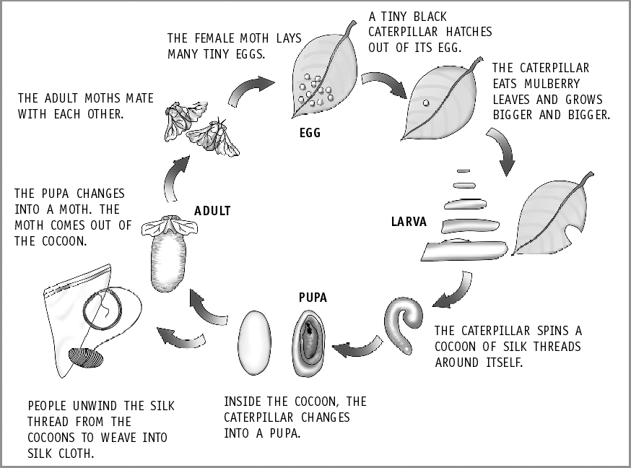
- a. Incubation: The silk moth eggs are warmed to a temperature suitable for hatching. This is known as incubation.
Living Science Companion – 7
  - Rearing: After hatching, the silkworms are fed on mulberry leaves for six weeks, and the worms eat almost continuously and increase in size.
  - Spinning: Branches of trees or shrubs are placed in their rearing houses. The worms climb these branches and make their cocoons out of one continuous thread.
  - Reeling: The cocoons are first boiled or treated in ovens, killing the insects by heat. The silk fibre is then obtained from the cocoons by a
8
delicate process known as reeling.
- Workers employed in the sericulture industry are adversely affected by a number of diseases.
  - Respiratory diseases: Inhalation of vapours arising from cocoons undergoing steaming, cooking and reeling produces breathing problems, asthma and other bronchial ailments.
  - Scabies and other skin infections: As a result of constant dipping of cocoons
in boiling water, the skin of the workers becomes raw and blistered, resulting in peeling of the skin of hands and feet.

